Animal Scientists - Reflection
Gwendolyn Overholt, Khadicha Nurakhmedov, Anthony Gandolfo, & Rachel Harankratt
This statistical analysis looks at patient encounter data gathered over four years to gain information about healthcare utilization trends and the evolution of patient experiences over time. This project looks at how people move through the healthcare system to find trends, gaps, and inefficiencies in care delivery. The problems we decided to face are: if continuity weakens at a distance threshold, if MyChart activation is associated with 30-day follow-ups, and is transportation and financial barriers an additional risk besides geography.
We looked at social determinants of health: Transportation/Financial Hardships, MyChart, and location. The methods we used to look at these social determinants of health was logistic regression looking at the odds of a 30-day follow-up based on our predictors: Distance (<5, 5-15, 15-30, 30+ miles), MyChart Status (activated, not activated, incomplete, complete), Age bracket, Year (2022), Transportation and Financial Hardship. We also did an adjusted pairwise contrast testing for the distances between patients and health services the map below shows the concentrations of patients compared to health service buildings.
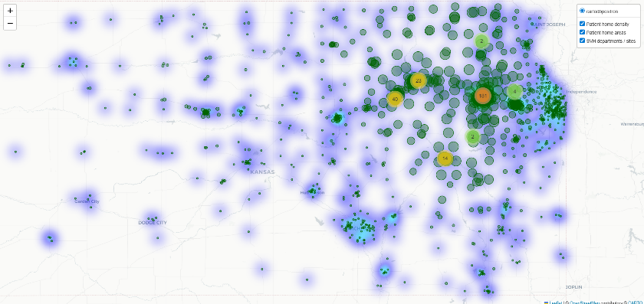
The outcome of our model founds that as the distance between patients and health services increases there is a less likely chance of the patient doing a follow-up visit. Particularly patients more than 30 miles away from health services had significantly lower chances P-value less than .001. The map shows a visualization of general patient locations in regard to health service building. Based on questionnaire answers we found that patients who have financial hardships had increased chances of follow-up appointments. Additionally, the model found that patients who either did not activate or completed their MyChart had lower chances of a follow-up withing 30-days.
The interpretation we gathered form this was that patients that are further from health services and with transportation hardships, and those that are less engaged with MyChart are less likely to return to utilize health services. While those with financial hardships had higher chances of returning for follow-ups. Our recommendation to health services that use MyChart is for them to be more proactive about reminding patients about MyChart.

Github Link for code: https://github.com/Khadichakhon/DataFest2026_AnimalScientistsTeam.git

